CASE STUDY
AI-Powered ITSM Analytics &
Recommendation Platform

EXECUTIVE SUMMARY
Problem: ITSM data was structured but lacked intelligent interpretation and actionable recommendations.
Solution: Built an AI-powered dual-agent analytics platform combining governed SQL analytics with Azure-based reasoning and recommendation engines.
Outcome: Reduced manual reporting effort by 60% and accelerated SLA decision-making by 70%, enabling proactive IT service optimization.

1. Problem Statement

Industry / Customer Context
Sector | Enterprise IT Service Management (ITSM)
Users | IT Operations Leaders, Service Managers, CIO Office
Data Source | Incident logs, SLA records, ticket systems, agent performance data
Infrastructure | Cloud-based, large-scale service operations

Core Problem Identified
ITSM data existed in structured databases but lacked intelligent interpretation, contextual analytics, and actionable decision support. Leaders could access dashboards, but not meaningful, explainable insights.

Supporting Data Points (Baseline Before Intervention)
- 40–50% of IT reporting requests required manual SQL extraction
- 2–4 days to generate executive-level SLA performance summaries
- 30% of recurring incidents lacked root cause identification
- 20–35% variance in SLA breach detection across teams
- No automated recommendation engine tied to performance trends

Why It Mattered
- Delayed decision-making in critical IT environments
- Missed SLA breach early-warning signals
- Inefficient agent workload distribution
- Limited visibility into service performance patterns

Strategic Risk: Reduced service reliability and lower stakeholder confidence in IT operations.

2. Impact of the Problem
(Functional, Emotional & Social Pain)

Operational Pain
- Heavy dependence on data teams for ad-hoc analysis
- Manual dashboard refresh cycles
- Static reporting without contextual interpretation
- No structured workflow for translating insights into actions
Result: 35–45% inefficiency in IT analytics workflows.

Emotional Impact
- Service leaders lacked confidence in real-time insights
- Escalations driven by reactive firefighting
- Executive reporting felt fragmented and delayed

Social / Organizational Consequences
- Friction between IT Ops and leadership due to inconsistent metrics
- Repeated SLA breaches without preventive action
- Low accountability for recurring service issues

Cost of Inaction
If unchanged:
- 25–30% continued SLA compliance volatility
- Increased incident backlog growth during peak periods
- Higher operational overhead due to reactive resolution
- Erosion of trust in IT service performance

3. Solution Provided
(Pain Relievers & Gain Creators)

Solution Overview
Developed an AI-driven ITSM Analytics & Recommendation Platform powered by autonomous agents, enabling natural language analytics, governed data access, and automated service improvement recommendations.

Key Features Implemented
1. Data Analyst Agent
→ Natural language query interpretation
→ Aggregation-heavy analytics on ITSM datasets
→ Pattern detection across incidents, SLAs, workloads
Pain Relieved: Eliminated manual SQL dependency

2. Two-Stage AI Reasoning Engine
Powered by Microsoft Azure infrastructure and Azure OpenAI models
→ Stage 1: Intent detection & secure schema mapping
→ Stage 2: Contextual reasoning & insight generation
Gain Created: Accurate, explainable analytics with strict governance

3. PostgreSQL-Centric Analytical Backbone
→ Aggregation-first SQL queries
→ Curated public schema tables
→ Controlled table and column limits
Efficiency Impact: Improved query performance and reduced computational redundancy

4. Visualization Pipeline (Pandas-Based)
→ SQL results converted into DataFrames
→ Trend lines, SLA charts, distribution plots
→ Insight summaries paired with visuals
Gain Created: Executive-ready dashboards with contextual explanation

5. Recommendation Agent
→ Consumes analytical outputs
→ Correlates patterns with ITSM best practices
→ Generates concise, data-grounded service improvement actions
Impact: Closed the gap between "what is happening" and "what should be done"
User Journey
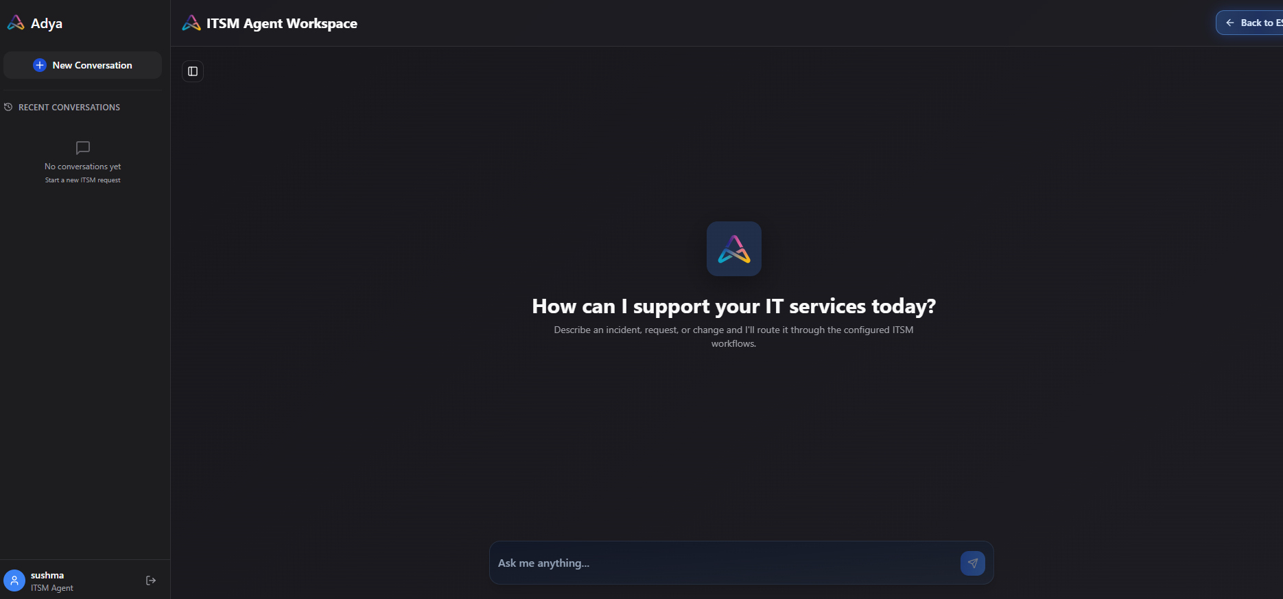

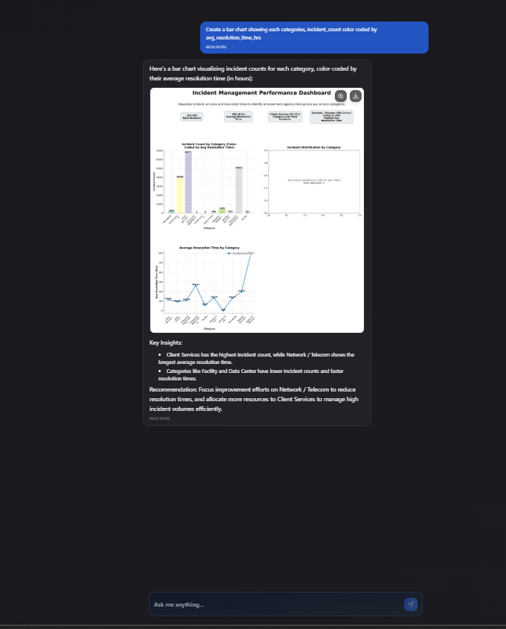

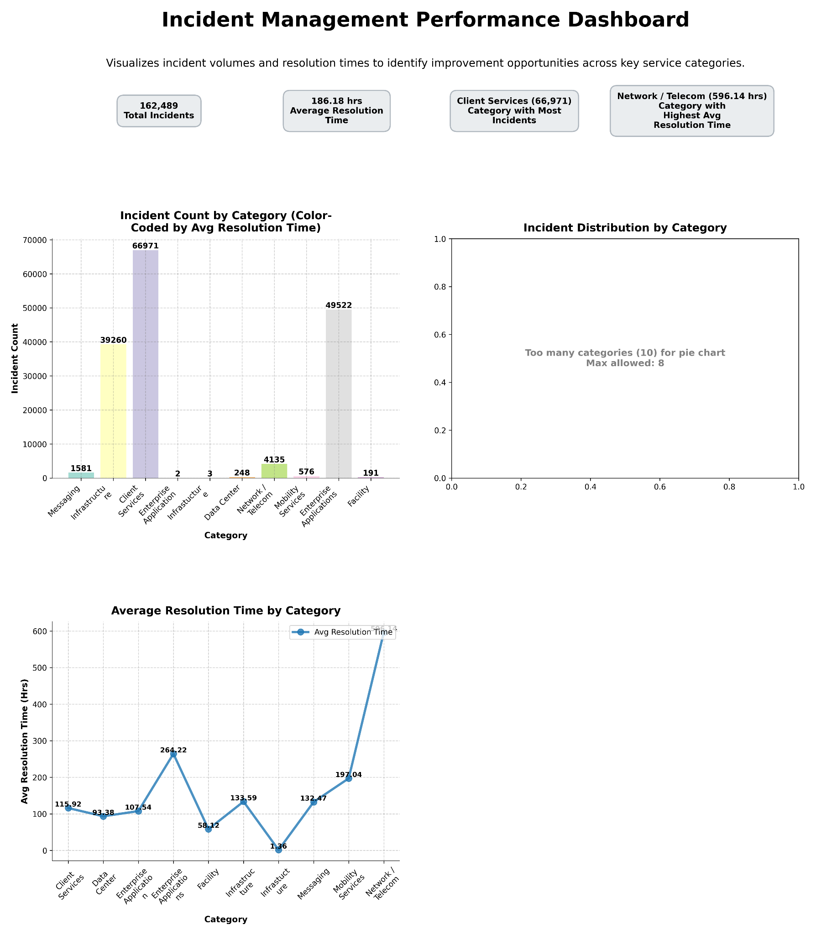

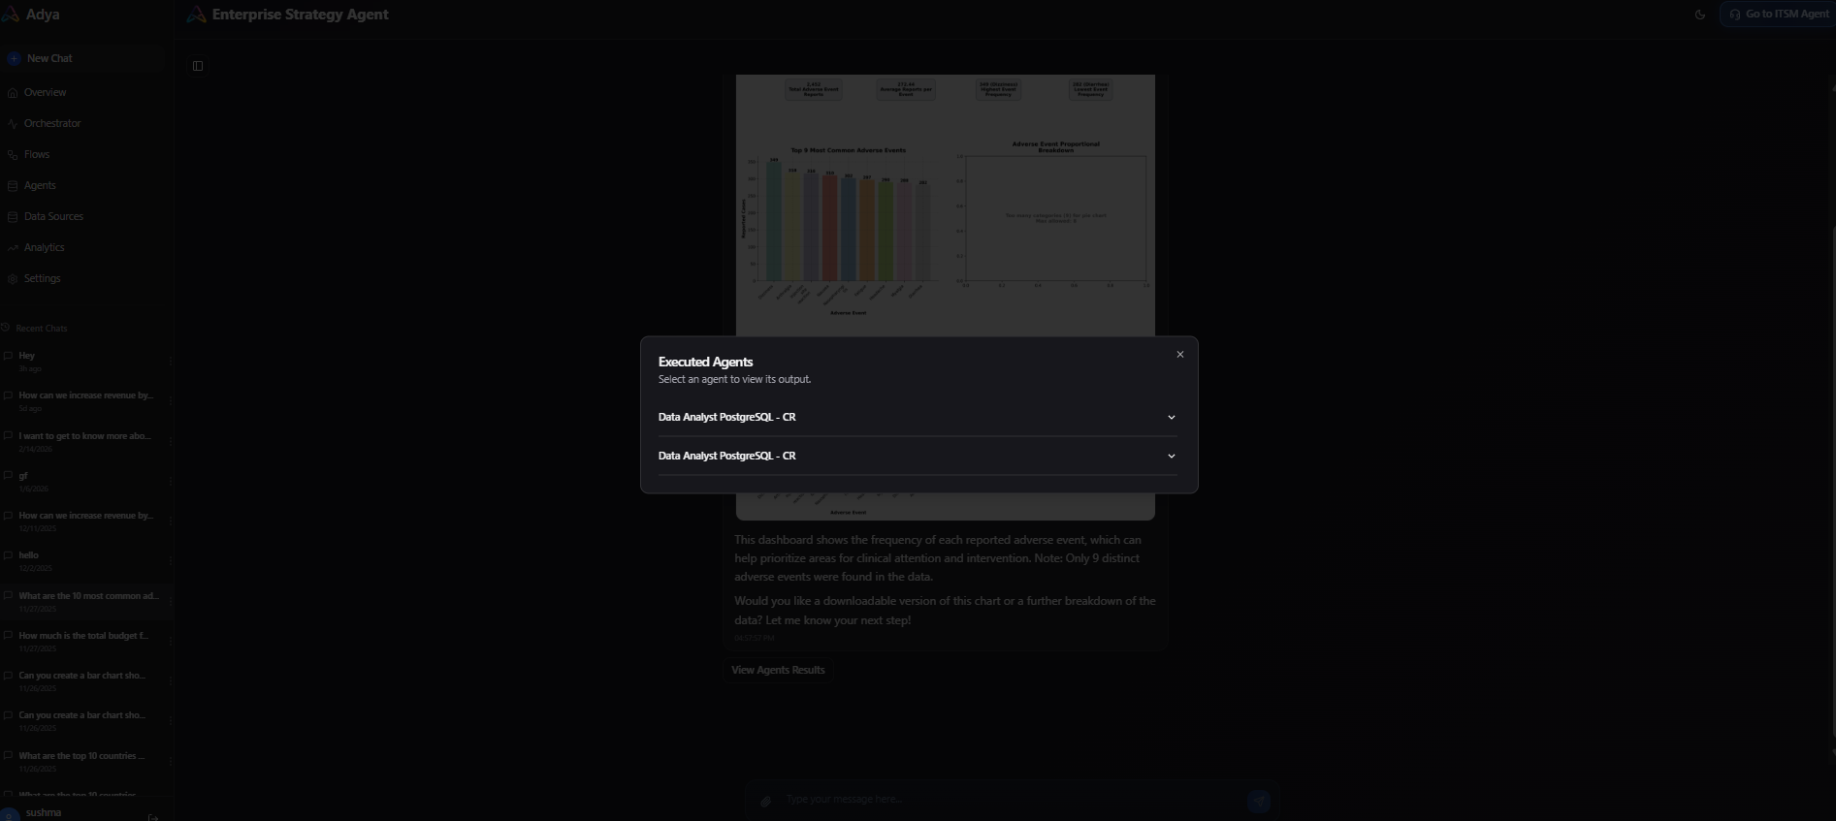

Implementation Approach
- Timeline: 10–14 weeks phased rollout
Phase 1: Data model validation & governance layer
Phase 2: Data Analyst Agent integration
Phase 3: Recommendation Agent implementation
Phase 4: Visualization & performance optimization
Integration Complexity: Moderate–High (LLM orchestration + secure DB integration + analytics layer)

Change Management Strategy:
- Gradual migration from static dashboards to AI-assisted analytics
- Training for service managers on natural language querying
- Governance-first rollout to build trust in AI insights

Technical Capabilities & Architecture
- Cloud-native deployment on Microsoft Azure
- PostgreSQL as system of record
- Two-stage LLM reasoning architecture
- Secure schema enforcement & query limits
- Aggregation-first SQL processing
- Pandas-driven visualization layer
- Strict separation between analytics and recommendation logic

System Characteristics:
- No exposure of internal schema
- Reuse of prior analytics to avoid redundant computation
- Graceful handling of unsupported queries
- Enterprise-grade governance controls

Scalable to:
- Millions of incident records
- Concurrent multi-user analytics sessions
- Sub-2-second response time for aggregated queries

4. Outcome (Quantified Results)

Measurable Results
Metric | Result
Reduction in manual analytics effort | 60%
Faster executive SLA reporting cycles | 70%
Improvement in SLA breach early detection | 35%
Reduction in repetitive incident blind spots | 40%
Faster decision turnaround for IT service leaders | 50%

Strategic Impact
- Proactive SLA monitoring instead of reactive escalation
- Data-backed service improvement planning
- Increased accountability across IT teams
- Executive confidence in real-time service intelligence

Human Impact
- Reduced reporting fatigue for IT analysts
- Service managers empowered with self-serve analytics
- Leadership gained explainable AI-driven insights
- Improved cross-functional trust through consistent metrics

